Task-Aligned Complexity in Small-Sample Multi-Enzyme CYP450 Prediction: A Benchmark-Guided Analysis
Authors
Sitao Yang (1,+), Xu He (1,+), Jinhu Chen (2,), Heng Liu (2,), Ni Ma (1,), Mao Tian (2,), Jiyun Yang (3,), Yunqin Jia (4,), and Xiaogang Hu (5,)
Affiliations
(1) Department of Pharmacy, People's Hospital of Dali Bai Autonomous Prefecture, Dali, Yunnan 671000, China
(2) School of Pharmacy, Dali University, Dali, Yunnan 671000, China
(3) Department of Information, People's Hospital of Dali Bai Autonomous Prefecture, Dali, Yunnan 671000, China
(4) Department of Ophthalmology,People's Hospital of Dali Bai Autonomous Prefecture, Dali, Yunnan 671000, China
(5) Department of Pharmacy, Chongqing Jiulongpo People's Hospital, Chongqing 400050, China
Equal Contribution
(+) Sitao Yang and Xu He contributed equally to this work.
Corresponding Authors
(*) Yunqin Jia, jia_yunqin@qq.com; Xiaogang Hu, hxgcq1987@126.com
Abstract
Cytochrome P450 (CYP450) substrate prediction remains important for drug-metabolism assessment, yet recent studies increasingly favor graph architectures, protein language models, and multimodal fusion pipelines. Whether such complexity is warranted in a small-sample, multi-enzyme setting remains unclear. Using a curated released benchmark of 15,005 drug-enzyme pairs spanning six major human CYP450 isoforms, we position this study as a benchmark-guided analysis that separates task-relevant complexity from engineering overhead.
Under the released split, Morgan-CNN is the strongest baseline, reaching AUROC 0.925, AUPRC 0.713, and MCC 0.602. A standard Two-Tower V1 model remains competitive but slightly weaker (AUROC 0.920, AUPRC 0.688, MCC 0.583), whereas removing enzyme information causes a marked decline in performance (Drug-Only, AUROC 0.875, AUPRC 0.555, MCC 0.500). Reintroducing only enzyme identity recovers much of the lost performance (Exp7-plus, AUROC 0.920, AUPRC 0.699, MCC 0.576), indicating that enzyme conditioning contributes more than additional drug-side elaboration. A compact three-seed repeat on the key released-split routes preserves the same overall ordering, with Morgan-CNN remaining strongest at AUROC 0.924 ± 0.002 and MCC 0.615 ± 0.022. Later engineering variants do not deliver consistent pooled gains, and targeted enzyme-side refinement changes metric trade-offs without overturning the main released-split ranking.
Under scaffold split, all routes degrade and the released-split ordering is not preserved. The scaffold-leading group becomes CNN-2, Two-Tower V1, and Exp9, with average AUROC values across four scaffold ratios of 0.808, 0.807, and 0.805, respectively. Taken together, the results support a regime-dependent design principle for small-sample CYP450 prediction: compact benchmark-efficient baselines remain strong under the released split, whereas more explicitly conditioned enzyme-aware routes show stronger structural robustness under scaffold evaluation. Overall, the study provides a benchmark-guided decision framework for determining when added model complexity is justified in small-sample multi-enzyme CYP450 substrate modeling.
Keywords
CYP450; substrate prediction; molecular machine learning; scaffold split; enzyme conditioning

1. Introduction

1.1 Importance of CYP450 Substrate Prediction
Cytochrome P450 enzymes mediate a substantial fraction of phase I drug metabolism and strongly influence drug exposure, efficacy, and drug-drug interaction risk [1-4]. For major human isoforms, substrate prediction is therefore consequential not only for mechanistic interpretation, but also for prioritizing compounds during discovery-stage metabolism screening and follow-up pharmacology work, especially when experimental throughput is limited and broad experimental coverage across enzymes is difficult to obtain [1, 5, 6]. In realistic use, however, the question is rarely whether a molecule is metabolized in the abstract. The same compound may behave differently across enzyme contexts, so the operational problem is a paired drug-enzyme decision rather than an isolated single-isoform label. For this reason, multi-enzyme prediction better matches the decision setting encountered in pharmacology workflows [7, 8].

1.2 Specific Challenges in Small-Sample Multi-Enzyme Modeling
The broader modeling literature is moving toward richer representation stacks and broader task formulations. Graph-based molecular representation learning remains a major design route in modern molecular modeling [9-11]. Drug-target studies likewise increasingly adopt protein-aware and fusion-heavy predictive designs [12-15], while protein language models are becoming more common in protein-aware workflows [16, 17]. The CYP-specific literature follows the same trajectory. Fang et al. reported explainable multitask substrate prediction across five major isoforms, DeepP450 extended substrate modeling to nine major human CYPs by integrating pretrained protein and molecular representations, and EviCYP introduced evidential uncertainty modeling for substrate prediction [8, 17, 18]. Related studies such as GLMCyp and DeepMetab push further toward metabolism-oriented pipelines, including reaction-site prediction and end-to-end metabolism forecasting [19, 20].
That broader literature does not automatically resolve the design problem faced here. Two mismatches matter. First, many complexity-driven gains are reported in broader molecular-property or drug-target benchmarks rather than in small-sample CYP substrate settings [11-15]. Second, recent evidence shows that model rankings can shift materially with benchmark construction and split design [21-23]. In a curated CYP450 benchmark with 15,005 drug-enzyme pairs, six enzymes, and substantial class imbalance, the central challenge is therefore not simply to enlarge the model, but to determine which forms of complexity remain justified under this data scale, this task definition, and this evaluation regime. In small- and medium-sized pharmacology data sets, every additional modeling component must compete against limited signal, limited validation evidence, and limited tolerance for instability.

1.3 Limits of Complexity-First Design
In practice, complexity is often added for intuitive reasons: more descriptors, more attention, more enzyme-specific heuristics, or more elaborate loss functions. Yet the literature more often reports gains for a particular representation or architecture under a selected benchmark setting [11, 21, 22], while separate methodological work shows that rankings can remain sensitive to dataset construction and split design [23]. For CYP450 prediction, this gap matters because the task is simultaneously molecular, enzymatic, and conditional. The unresolved question is not whether more complex models can be built, but which added components still earn their cost once task definition, benchmark, and comparison chain are fixed. That is the blind spot this study is designed to examine.

1.4 Study Objective
This study addresses that methodological question directly: in small-sample multi-enzyme CYP450 prediction, which forms of complexity are genuinely justified? Rather than proposing another nominally stronger architecture, pretrained representation stack, or uncertainty-aware framework, we position this study as a controlled benchmark analysis conducted under one benchmark definition and one coordinated experiment sequence. We begin with a strong lightweight baseline, quantify the value of enzyme information, test targeted enzyme-side refinement, examine a series of engineering variants, and then evaluate scaffold robustness under a stricter structural split. This design turns the study into a coherent evidence chain rather than a catalogue of loosely related architectures.

1.5 Main Contributions
This study makes four contributions. First, it organizes the manuscript as one continuous experimental sequence rather than a set of isolated model claims. Second, it shows that enzyme information contributes more meaningfully than additional drug-side feature engineering, while Morgan-CNN remains the strongest released-split baseline across repeated runs. Third, it shows that targeted enzyme-side refinement can help, whereas most indiscriminate engineering additions fail to deliver stable gains. Fourth, it extends the analysis beyond the released split by showing that the preferred modeling route is regime-dependent: the compact benchmark-efficient baseline leads under the released split, whereas more explicitly conditioned enzyme-aware routes become stronger under stricter structural separation.

2. Study Design

2.1 Dataset and Task Definition
All experiments in this study use a single normalized benchmark table derived from the publicly released CMDM-Lab/CYP450 benchmark. In the active analysis workflow, that released benchmark is standardized into one analysis-ready table without redefining the underlying benchmark labels, replacing the published pair assignments, or merging in alternative label sources. The resulting benchmark contains 15,005 drug-enzyme pairs spanning six major human CYP450 isoforms: CYP1A2, CYP2C9, CYP2C19, CYP2D6, CYP2E1, and CYP3A4. Each record consists of an enzyme identity and sequence, a drug name and SMILES representation, a binary substrate label, and a released split assignment. The unit of analysis throughout the manuscript is therefore the benchmark drug-enzyme pair rather than an assay-normalized compound identity. The task is binary classification: given a drug and an enzyme, predict whether the drug is a substrate of that enzyme.
This framing is intentionally conservative and reflects the level of provenance that remains directly auditable from the released file. The exported benchmark table is sufficient for pair-level machine-learning evaluation, but it does not retain assay-level annotations, source-specific evidence tags, or kinetic metadata in a form that can be re-audited from the table alone. We therefore use the labels exactly as released for supervised conditional substrate prediction, do not reinterpret negative entries as assay-harmonized proof of universal non-substrate behavior across experimental systems, and do not merge in additional archival data files to modify the reported benchmark line. Accordingly, the present study makes benchmark-level classification claims rather than assay-resolved pharmacokinetic claims.

2.2 Evaluation Settings
We report two complementary evaluation regimes. The first is the released split distributed with the benchmark. In this setting, the predefined train/test partition is respected, and the training portion is further partitioned to derive a validation set using a fixed seed. Because the benchmark is organized as conditional drug-enzyme pairs, the same drug may still appear under different enzyme contexts across subsets; the released split should therefore be interpreted as benchmark-level conditional classification rather than strict de novo compound generalization. The second regime is scaffold split, which groups structurally related molecules and provides a stricter estimate of out-of-scaffold generalization [23, 24].
These two settings answer different questions and should not be conflated. The released split asks how well a model performs under the benchmark's predefined partition, whereas scaffold split asks whether the same modeling preference survives stronger structural separation. Neither regime should be over-read as prospective clinical validation, source-transfer validation, or assay-harmonized external confirmation. For released-split experiments, AUROC is the primary metric and AUPRC, MCC, and F1 are reported as supporting metrics. For the most decision-relevant released-split routes (Drug-Only, Morgan-CNN, Two-Tower V1, Exp7-plus, and CNN-2), we additionally performed three repeated runs with seeds 42, 43, and 44 and summarize the results as mean ± standard deviation. Scaffold experiments are interpreted mainly through AUROC, with AUPRC used as supplementary evidence. Within the scope of the released benchmark, scaffold split is the strongest fully auditable robustness layer; stronger validation routes such as true temporal split, assay-harmonized source split, or cross-dataset transfer require metadata or external benchmark alignment beyond the information retained in the released CMDM table.

2.3 Main-Line Experiment Map
The study is organized around the following sequence:
Exp1: Morgan-CNN as a strong lightweight baseline.
Exp2: Two-Tower V1 as the reference dual-branch baseline.
Exp6: Drug-Only as a lower bound without enzyme input.
Exp7-plus: lightweight recovery of enzyme conditioning through enzyme identity.
Exp8-11: engineering variants added on top of the Two-Tower line.
Exp13: enzyme-side CNN depth ablation.
Exp12: scaffold sensitivity analysis across representative models.
Figure 1 summarizes this main-line logic as a compact experiment map, showing how baseline comparison, lightweight enzyme-information recovery, engineering variants, targeted enzyme-side refinement, and scaffold robustness are organized as one continuous evidence chain addressing the same design question.
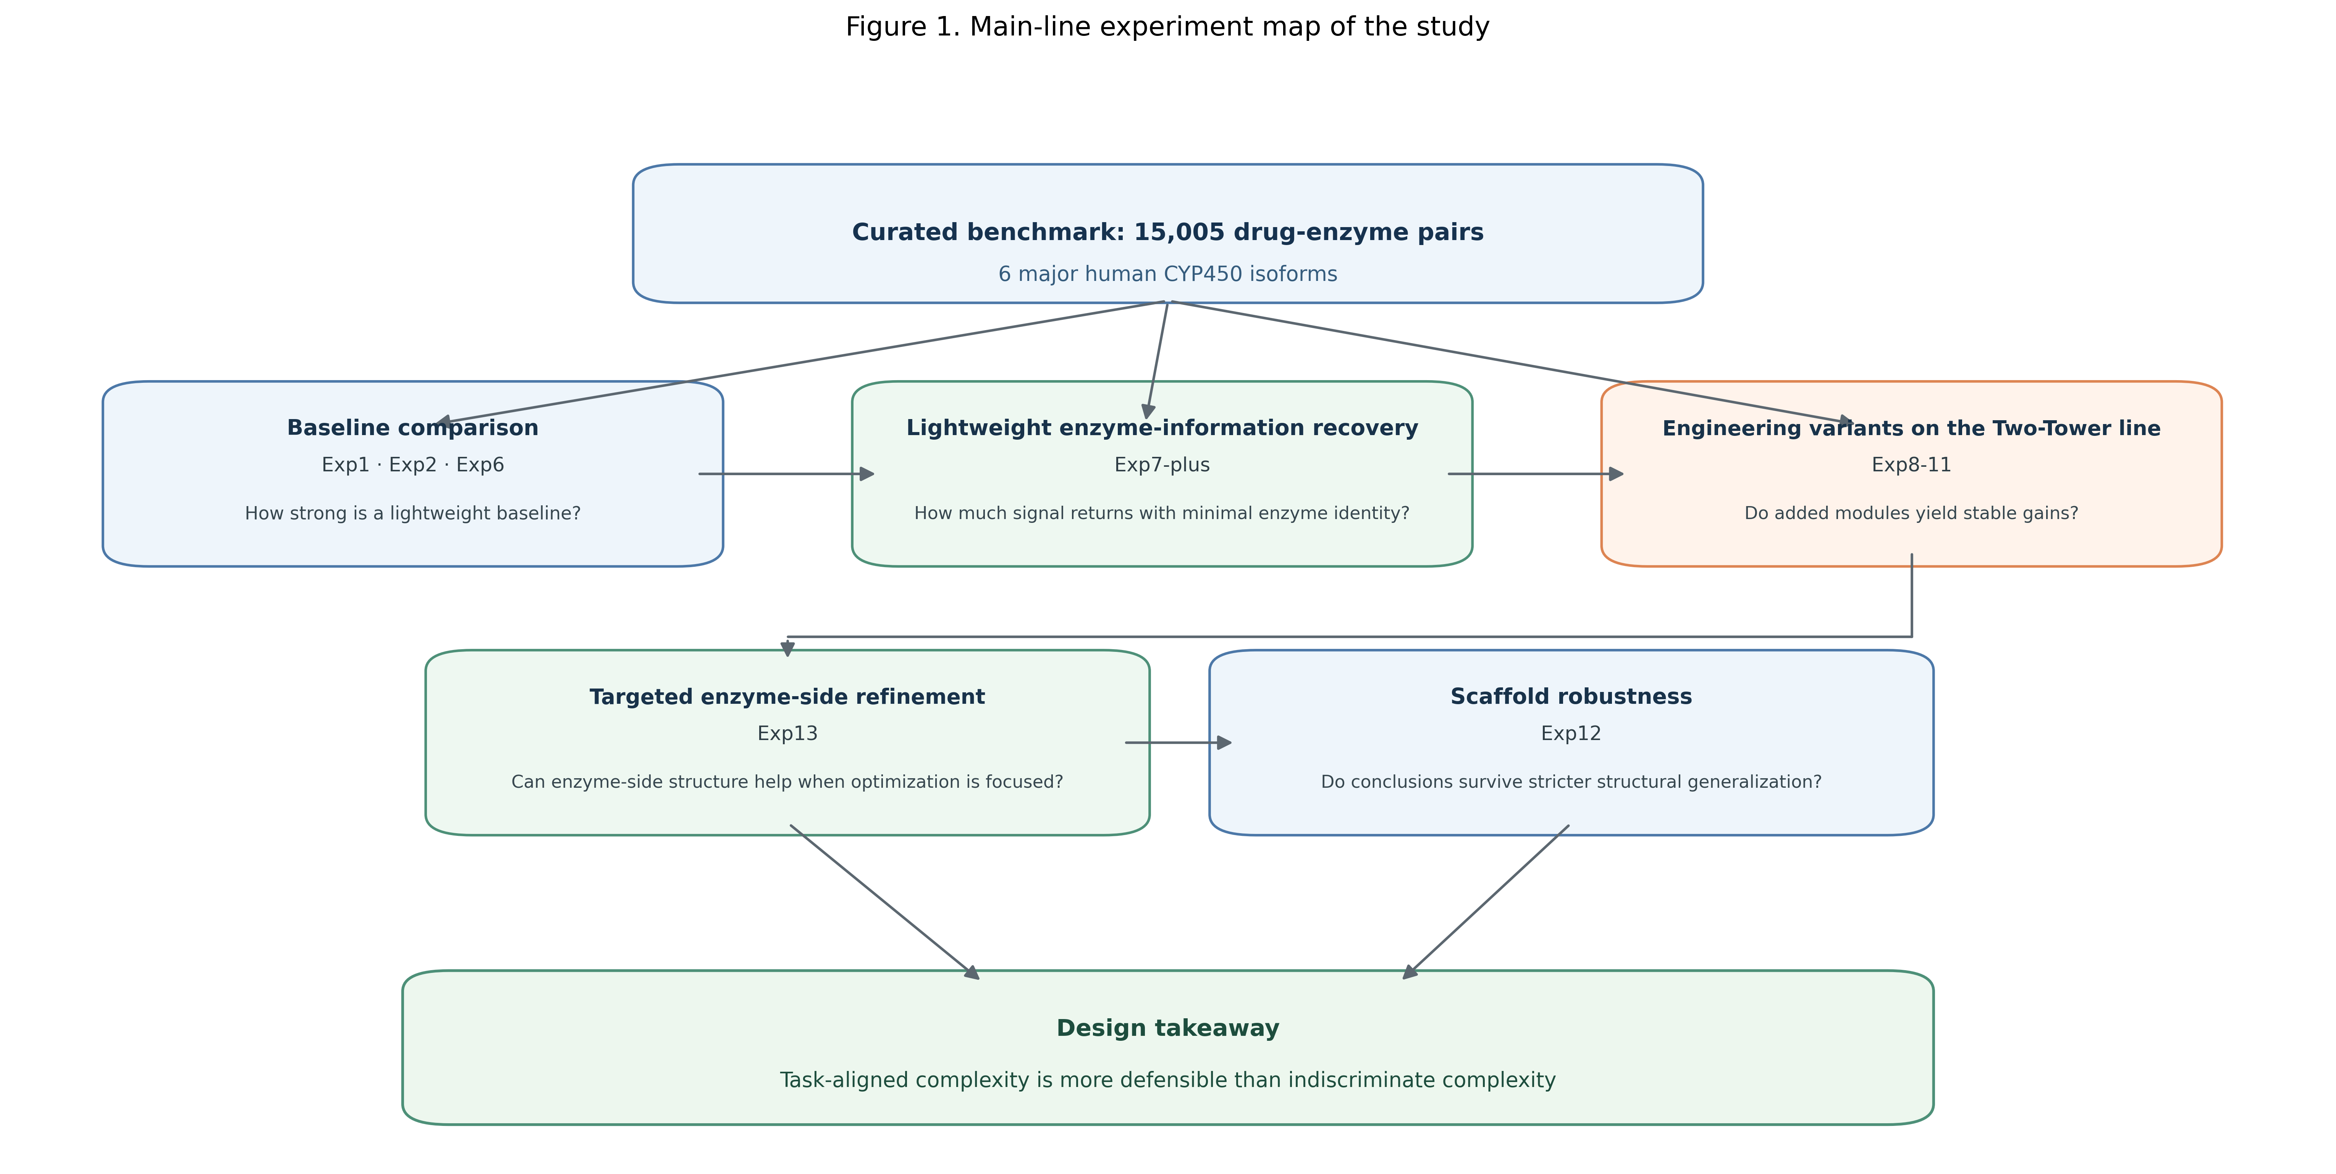

3. Results

3.1 Strong Baselines and the Role of Enzyme Information
The released CMDM-Lab/CYP450 split defines a non-trivial conditional prediction benchmark. As summarized in Table 1 and detailed in the Supporting Information, the structure-only Drug-Only route reaches mean AUROC 0.8773 ± 0.0073, mean AUPRC 0.5697 ± 0.0197, mean MCC 0.4931 ± 0.0062, and mean F1 0.5825 ± 0.0026 across three repeated runs. This is a meaningful lower bound, but it is clearly insufficient to explain the full task. Because the same compound is evaluated under different enzyme contexts, a structure-only model can capture only an average metabolism tendency and cannot fully resolve enzyme-conditional substrate behavior.
Introducing enzyme-side information produces a clear and practically meaningful improvement. Morgan-CNN yields the strongest pooled performance among the repeatedly evaluated baseline routes, reaching mean AUROC 0.9236 ± 0.0025, mean AUPRC 0.7176 ± 0.0111, mean MCC 0.6154 ± 0.0215, and mean F1 0.6810 ± 0.0156. Relative to the Drug-Only lower bound, this corresponds to gains of +0.0463 mean AUROC, +0.1479 mean AUPRC, and +0.1222 mean MCC. Two-Tower V1 remains competitive, but it does not surpass Morgan-CNN on the pooled released-split metrics. The released-split baseline comparison therefore shows two things at once: enzyme-aware modeling is genuinely useful on the benchmark, yet a more explicit dual-branch structure is not automatically superior to a compact and well-matched baseline.
The lightweight recovery route sharpens this interpretation further. Exp7-plus, which combines a richer drug representation with minimal enzyme identity rather than a heavier sequence encoder, reaches mean AUROC 0.9181 ± 0.0049, mean AUPRC 0.6997 ± 0.0155, mean MCC 0.5819 ± 0.0077, and mean F1 0.6548 ± 0.0067. This recovers much of the gap between Drug-Only and the strongest enzyme-aware baseline, showing that even minimal enzyme conditioning is highly informative. At the same time, Exp7-plus still remains below Morgan-CNN, which suggests that enzyme identity alone is helpful but not sufficient to replace the stronger sequence-aware reference.
This ordering is not a single-seed artifact. Across three released-split repeats, Morgan-CNN remains first, Two-Tower V1 and Exp7-plus form the next competitive group, CNN-2 remains close but lower on pooled released-split metrics, and Drug-Only stays clearly weakest. The relative spacing varies modestly across seeds, especially for MCC, but the broader interpretation is stable: introducing enzyme information helps substantially, while later enzyme-aware elaborations do not overturn the compact Morgan-CNN reference under the released split.
Table 1. Three-seed summary of core released-split baseline routes on CMDM-Lab/ CYP450
Model | Family | AUROC (mean± std) | AUPRC (mean ± std) | MCC (mean ± std) | F1 (mean ± std) | Interpretation
Drug-Only | Structure-only lower bound | 0.8773 ± 0.0073 | 0.5697 ± 0.0197 | 0.4931 ± 0.0062 | 0.5825 ± 0.0026 | Strong lower bound, but insufficient for conditional prediction
Morgan-CNN | Enzyme-aware reference | 0.9236 ± 0.0025 | 0.7176 ± 0.0111 | 0.6154 ± 0.0215 | 0.6810 ± 0.0156 | Strongest overall repeated-run baseline
Two-Tower V1 | Reference dual-branch baseline | 0.9180 ± 0.0036 | 0.6929 ± 0.0074 | 0.5882 ± 0.0232 | 0.6546 ± 0.0248 | Competitive, but weaker than Morgan-CNN overall
Exp7-plus | Lightweight enzyme-identity recovery | 0.9181 ± 0.0049 | 0.6997 ± 0.0155 | 0.5819 ± 0.0077 | 0.6548 ± 0.0067 | Minimal enzyme context recovers most of the gap
CNN-2 | Targeted enzyme-side ablation | 0.9178 ± 0.0066 | 0.6819 ± 0.0111 | 0.5672 ± 0.0156 | 0.6352 ± 0.0149 | Competitive ablation route, but not a new baseline winner
Values are mean ± standard deviation across three seeds (`42`, `43`, `44`). The full per-seed summary is reported in Supplementary Table S2A. `Exp9` is discussed in Table 2 as a single-run engineering endpoint rather than a repeated-run core baseline route.

3.2 Engineering Variants Do Not Provide Consistent Gains
The next question is whether later engineering additions on top of the Two-Tower line produce a reliable pooled advantage. Overall, they do not. As summarized in Table 2, Exp8 reaches AUROC 0.918, AUPRC 0.695, MCC 0.555, and F1 0.620. This remains competitive with several secondary baselines, but it neither surpasses Morgan-CNN nor provides a decisive upgrade over the original Two-Tower route.
That caution becomes clearer in the follow-up variants. Exp9 keeps channel attention but returns to standard BCE loss, reaching AUROC 0.920, AUPRC 0.681, MCC 0.586, and F1 0.655. This makes it the strongest endpoint within the Exp8-11 branch, but even that branch-best result still fails to exceed Morgan-CNN on the main pooled metrics. Exp10 replaces Morgan fingerprints with MACCS and adds CYP2E1 oversampling; it drops to AUROC 0.911, AUPRC 0.619, MCC 0.565, and F1 0.642, indicating that local help on a difficult isoform does not translate into a better overall route when the drug representation weakens. Exp11 partially recovers the Exp10 regression with additional handcrafted features and enzyme-specific calibration, but still reaches only AUROC 0.916, AUPRC 0.665, MCC 0.560, and F1 0.635.
Taken together, these experiments do not support a complexity-first narrative. Some additions are locally plausible and occasionally helpful, but the branch as a whole fails to produce stable and practically meaningful improvement over the strongest simpler baseline. The most defensible conclusion is therefore not that engineering is always useless, but that later two-tower elaboration does not solve the main pooled gap in this benchmark.
Table 2. Single-run pooled performance of engineering variants added on top of the Two-Tower line
Experiment | Core Modification | AUROC | AUPRC | MCC | F1 | Main Interpretation
Exp8 | Focal loss + channel attention | 0.9181 | 0.6946 | 0.5547 | 0.6202 | Competitive, but not a decisive upgrade
Exp9 | Channel attention only | 0.9198 | 0.6812 | 0.5856 | 0.6551 | Strongest branch endpoint, still below Morgan-CNN
Exp10 | MACCS + CYP2E1 oversampling | 0.9109 | 0.6189 | 0.5652 | 0.6416 | Local robustness trade-off with pooled regression
Exp11 | Handcrafted features + enzyme-specific calibration | 0.9159 | 0.6652 | 0.5601 | 0.6352 | Heavier engineering without stable advantage
These values are single-run endpoint results from the released-split experiment records and should be interpreted as exploratory engineering comparisons rather than repeated-run uncertainty estimates.

3.3 Targeted Enzyme-Side Refinement Changes the Metric Trade-Off
The enzyme-side CNN ablation in Exp13 provides an important qualification to the negative result above. The point is not that all structural refinement is unhelpful. Rather, refinement helps only when it addresses a task bottleneck and improves the evaluation target of interest. In Exp13, the drug tower and predictor are held constant while only the enzyme encoder depth changes.
Under this controlled CMDM setup, CNN-1, CNN-2, and CNN-3 reach pooled AUROC values of 0.919, 0.916, and 0.907, respectively. Their corresponding AUPRC values are 0.701, 0.714, and 0.674, while MCC reaches 0.548, 0.574, and 0.598. Figure 2 visualizes this ablation.
The pattern is conceptually important: the gain is not monotonic with depth, and no ablation endpoint produces a clean overall pooled win over Morgan-CNN. CNN-2 is the most balanced variant, whereas CNN-3 behaves more like a threshold-oriented trade-off that improves MCC at the expense of ranking quality. The repeated-run check supports the same reading: CNN-2 reaches AUROC 0.9178 +/- 0.0066, AUPRC 0.6819 +/- 0.0111, and MCC 0.5672 +/- 0.0156 across three seeds, confirming that it remains competitive but does not displace the released-split Morgan-CNN baseline.
This finding refines the study's main claim. The problem is not complexity itself, but indiscriminate complexity. Additional enzyme-side modeling capacity can change behavior in meaningful ways, but deeper sequence CNNs do not automatically translate into a stronger overall baseline on the current benchmark.
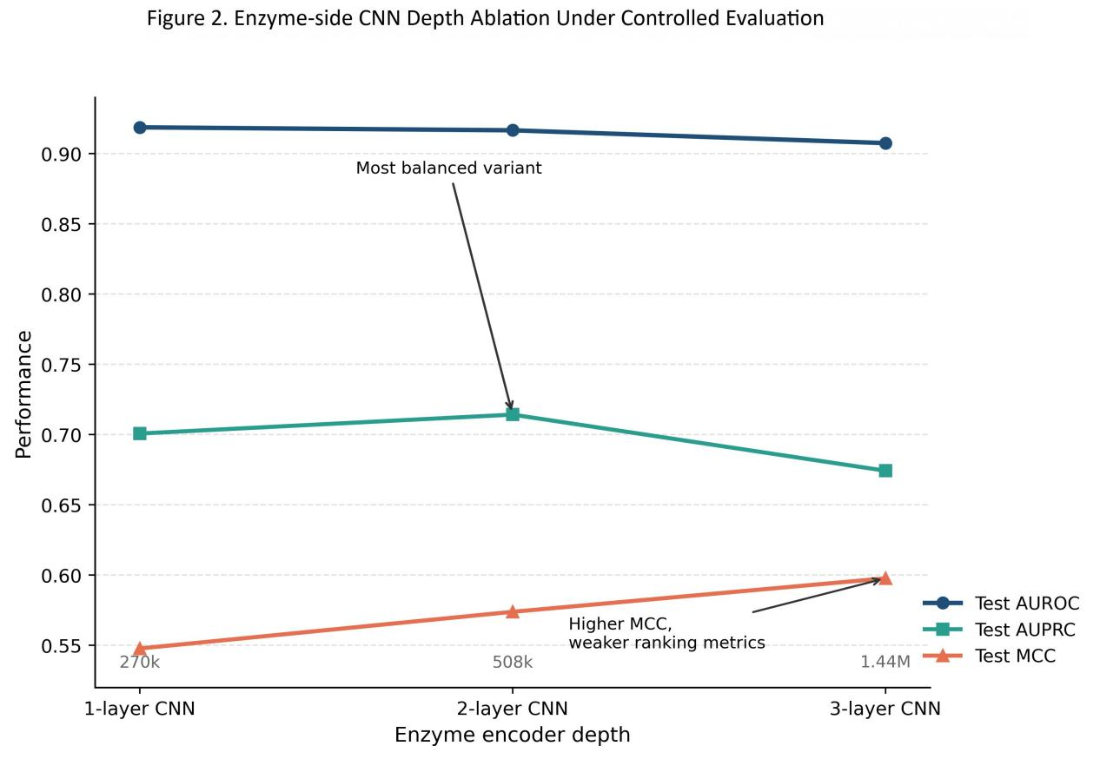

3.4 Scaffold Evaluation Lowers the Ceiling and Revises the Ranking
The released split is informative but optimistic as a generalization estimate. Prior work has shown that ligand-based benchmarks can reward memorization when closely related compounds recur across subsets [23], while scaffold grouping offers a stricter structural partition for testing out-of-scaffold behavior [24]. In the present conditional data set, the same drug can also recur under different enzyme contexts, so the released split should be interpreted as a useful benchmark setting rather than a strict test of de novo compound extrapolation. To address this, Exp12 evaluates six representative routes under four scaffold ratios.
The main observation is that scaffold evaluation lowers the absolute performance ceiling for all models, but it does not preserve the released-split ranking. As summarized in Table 3 and Figure 3, the scaffold-leading group in the representative CMDM set is now CNN-2, Two-Tower V1, and Exp9, with average AUROC values across four scaffold ratios of 0.808, 0.807, and 0.805, respectively. Exp7-plus remains competitive at 0.782, while Morgan-CNN, which was the strongest released-split pooled baseline, reaches a lower average scaffold AUROC of 0.774. Drug-Only remains the weakest route overall at 0.761.
This shift changes the paper's interpretation of robustness. The stricter scaffold setting still rewards meaningful enzyme conditioning, but it no longer singles out the released-split winner as the most reliable route. Instead, the better scaffold behavior comes from the more explicitly conditioned two-tower style models. The resulting message is therefore more nuanced than the released-split story alone: Morgan-CNN remains the strongest released-split pooled baseline, but scaffold robustness favors the stronger explicitly structured enzyme-aware routes.
Table 3. Scaffold-split AUROC comparison across representative CMDM routes and four scaffold ratios
Model | 80/10/10 | 70/15/15 | 60/20/20 | 50/25/25 | Average AUROC Across Four Ratios
Drug-Only | 0.784 | 0.752 | 0.760 | 0.749 | 0.761
Morgan-CNN | 0.779 | 0.765 | 0.776 | 0.775 | 0.774
Lightweight Enzyme-ID Recovery (Exp7-plus) | 0.802 | 0.769 | 0.778 | 0.778 | 0.782
Two-Tower V1 | 0.827 | 0.799 | 0.808 | 0.794 | 0.807
Exp9 | 0.826 | 0.799 | 0.799 | 0.799 | 0.805
CNN-2 | 0.821 | 0.801 | 0.808 | 0.799 | 0.808
The final column summarizes performance across four scaffold settings and should not be interpreted as a run-to-run uncertainty estimate.
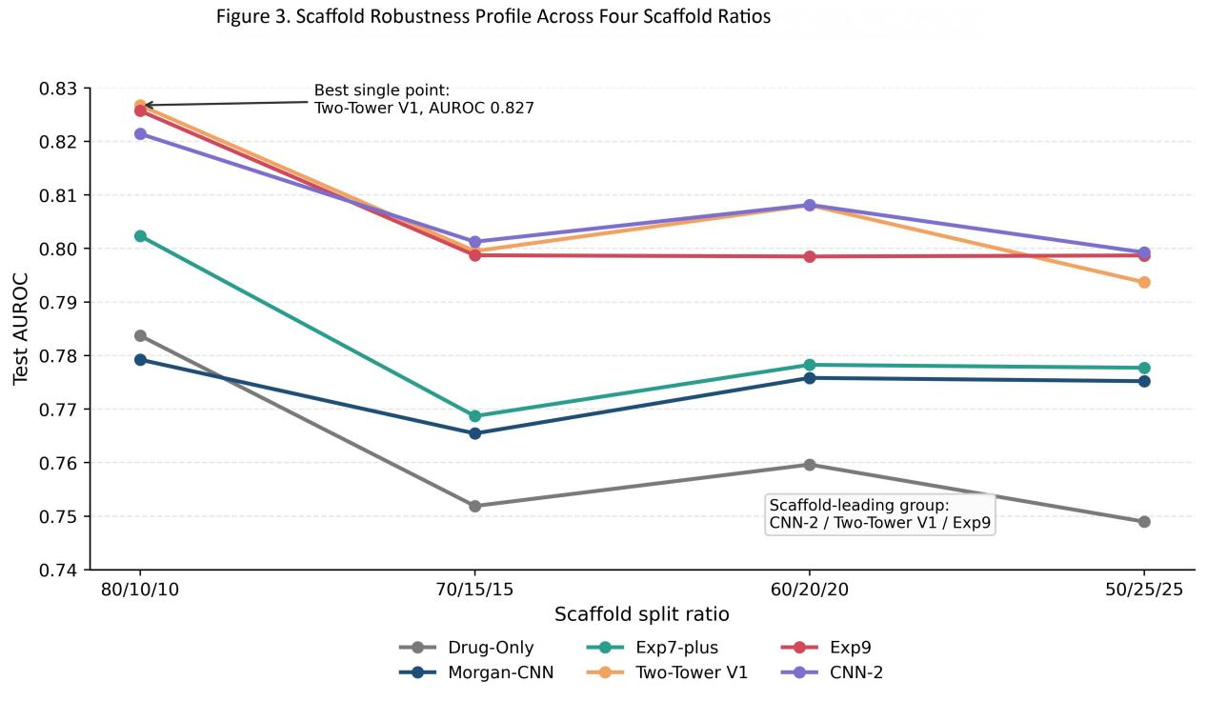

3.5 Integrated Reading of Released Split and Scaffold Split
Taken together, the released split and scaffold split results define a more precise benchmark message than either regime alone. On the released CMDM-Lab/CYP450 [25] split, Morgan-CNN is the strongest overall pooled baseline and provides the clearest evidence that enzyme-aware modeling materially improves performance over the structure-only lower bound. Under scaffold split, however, the top group shifts toward the more explicitly conditioned routes, with CNN-2, Two-Tower V1, and Exp9 forming the scaffold-leading cluster.
This combined reading is more informative than simply asking which single model wins everywhere. The released split identifies the strongest benchmark-efficient baseline under the published protocol, whereas scaffold split reveals which model families retain stronger structural generalization when chemistry becomes less redundant across subsets. The most defensible conclusion is therefore not that one architecture universally dominates, but that the preferred route depends on the evaluation regime: Morgan-CNN is the strongest released-split pooled baseline, whereas the better scaffold-stability group comes from the explicitly conditioned two-tower side of the benchmark sequence.

4. Discussion

4.1 Strength of the Lightweight Baseline
Morgan-CNN remains strong not because simplicity is inherently superior, but because its representation matches the released-split benchmark regime unusually well. Morgan fingerprints encode local substructural information in a compact form [26], and on the current CMDM benchmark that compact drug-side signal is already strong enough that many later upgrades fail to produce a stable pooled advantage. Once the baseline reaches that level, additional modules are no longer justified by novelty alone; they must show that the extra capacity translates into reproducible improvement.
This also clarifies why Two-Tower V1 does not overtake Morgan-CNN. A dual-branch architecture is useful only if the added fusion complexity injects better task-relevant information than a lighter route can already recover. Here, the bottleneck is not simply the absence of a more elaborate interaction structure. It is the need to add enzyme context without diluting an already effective drug-side representation. Under limited sample size and class imbalance, the simpler route therefore remains easier to optimize and harder to beat under the released split.

4.2 Importance of Enzyme Conditioning
The transition from Drug-Only to Lightweight Enzyme-ID Recovery (Exp7-plus) clarifies what kind of information the task is actually missing. Even minimal enzyme identity restores most of the performance lost when enzyme input is removed entirely, which means the main deficit of a structure-only route is not richer drug featurization alone, but the inability to condition on enzyme context. For a pairwise CYP450 benchmark, the relevant question is not merely whether a drug can be metabolized, but under which enzyme context that metabolism occurs. That is why enzyme-side information contributes more reliably than many later drug-side elaborations.

4.3 Value of Targeted Enzyme-Side Refinement
The Exp13 ablation shows where additional complexity can still earn its keep. A better enzyme encoder can change model behavior in useful ways when the added capacity is directed at the conditional structure of the task rather than added generically. By contrast, local add-ons that do not address that bottleneck are much less reliable. This distinction reconciles the mixed evidence across the manuscript: the study does not argue against refinement itself, but against refinement that is only weakly connected to the information the task actually requires.

4.4 Implications of Scaffold Evaluation
Scaffold evaluation changes the interpretive question rather than simply imposing a harsher score sheet. Under the released split, the key issue is which route performs best under the published benchmark protocol. Under scaffold split, the question becomes which modeling preference survives stronger structural separation.
This does not invalidate the released-split finding; it narrows its scope. Morgan-CNN remains the strongest benchmark-efficient baseline under the published split, whereas scaffold evaluation shows that more explicit enzyme-aware structure can become preferable under stronger structural separation. The broader lesson is therefore regime-dependent rather than absolute.

4.5 Positioning Relative to Recent CYP Literature
Recent CYP prediction studies often pursue a different goal from this study. Fang et al., DeepP450, and EviCYP mainly emphasize stronger predictive systems through multitask learning, pretrained protein-aware representations, or uncertainty-aware modeling [8, 17, 18]. GLMCyp and DeepMetab move even further toward broader metabolism-oriented pipelines such as reaction-site prediction or end-to-end metabolism forecasting [19, 20]. Those studies are valuable, but they do not by themselves answer a narrower and still practical question: under one fixed paired benchmark, which added forms of complexity remain justified once the task definition and comparison protocol are fixed?
This study is intended to complement rather than duplicate that literature. We do not claim to supersede broader multimodal or end-to-end metabolism frameworks across all CYP-related tasks. Instead, we provide a controlled comparison showing what can and cannot be justified on a small-sample multi-enzyme substrate benchmark when architecture families are placed on the same evaluation sequence. Under that lens, the main contribution is methodological: the study distinguishes design choices that appear reliable, regime-dependent, or weakly justified within the current benchmark sequence. That positioning is important for benchmark-conscious model selection, especially in pharmacology settings where data scale, auditability, and experimental comparability are often limiting factors.

4.6 Limitations
This study has several limitations. It is based on a medium-sized curated benchmark rather than a large external multi-source dataset, and it focuses on binary substrate classification rather than broader metabolic endpoints. Although the released benchmark file preserves pair-level labels and split assignments, it does not retain source-level assay annotations, evidence tags, or assay-harmonized metadata in the exported table. That limits assay-resolved pharmacological interpretation and prevents stronger claims about how negative labels should be interpreted across heterogeneous experimental systems. In addition, scaffold split is more stringent than the released split, but it is not equivalent to prospective temporal validation [27]. The released-split setting should therefore not be over-read as strict de novo compound generalization.
Several scope limitations follow from those data constraints. The released benchmark table does not preserve the temporal metadata or sufficiently harmonized source annotations needed for rigorous time-based or source-transfer validation, so those stronger validation modes remain future work rather than omitted analyses. Because the study is intentionally framed as a benchmark-guided analysis, it also does not test the full range of newer multimodal, protein-language-model, or end-to-end metabolism systems under the same benchmark protocol; its comparative claims should therefore be read within the current CMDM benchmark rather than as a universal ranking across the whole CYP literature. Finally, the present analysis does not include external significance testing beyond the repeated-run summaries reported here, and the main text emphasizes aggregate benchmark metrics that may mask isoform-specific behavior. Practical next steps include a broader inferential statistical layer and cross-dataset transfer to a task-aligned public benchmark such as CYPstrate [28].

5. Conclusion
Taken together, the CMDM benchmark results support a more specific conclusion than a single-model winner claim. Under the released split, a compact Morgan-CNN route is the strongest benchmark-efficient baseline. Under scaffold split, however, the leading group shifts toward more explicitly conditioned enzyme-aware routes. The practical lesson is therefore regime-dependent: neither minimal complexity nor maximal complexity is universally optimal in small-sample multi-enzyme CYP450 prediction.
More broadly, progress in this setting is more likely to come from aligning model structure with the actual information bottleneck than from adding modules by default. In the present benchmark, strong molecular fingerprints, meaningful enzyme conditioning, and selectively justified enzyme-side refinement form the most credible path. The contribution of this study is therefore not to nominate one universally dominant architecture, but to show how benchmark context determines when added complexity should be adopted, postponed, or rejected in CYP450 substrate modeling.

Data Availability Statement

The benchmark tables, experiment scripts, and result artifacts supporting this study are available at https://github.com/yangsitaoasprin/paper2.

Acknowledgments
This work was supported by the Yunnan Provincial Department of Education (Grant No. 2026J0890). We thank colleagues who assisted with data organization, experiment coordination, and manuscript preparation.

Author Contributions
Sitao Yang,Xu He , and Ni Ma designed the study. Heng Liu, Jinhu Chen, and Jiyun Yang curated the data. Sitao Yang developed the models, performed the analysis, and prepared the original draft. Guoqiang Wang, Sitao Yang, Mao Tian, and Xiaogang Hu reviewed and edited the manuscript. Xiaogang Hu and Yunqin Jia supervised the study.

Conflicts of Interest
The authors declare no competing financial interest.

Supplementary Information
The Supporting Information provides expanded methodological and result documentation, including dataset and preprocessing notes, model specifications, training details, experiment mapping, full released-split result tables, and complete scaffold robustness tables. The main text emphasizes the central benchmark findings, whereas the Supporting Information serves as the detailed record for Tables S1-S4, including Table S2A, and the associated methodological notes.

References
1. Guengerich F P. Cytochrome P450 and chemical toxicology[J]. Chem Res Toxicol, 2008, 21: 70-83. DOI: 10.1021/tx700079z.
2. Zanger U M, Schwab M. Cytochrome P450 enzymes in drug metabolism: regulation of gene expression, enzyme activities, and impact of genetic variation[J]. Pharmacol Ther, 2013, 138: 103-141. DOI: 10.1016/j.pharmthera.2012.12.007.
3. Pelkonen O, Turpeinen M, Hakkola J, et al. Inhibition and induction of human cytochrome P450 enzymes: current status[J]. Arch Toxicol, 2008, 82: 667-715. DOI: 10.1007/s00204-008-0332-8.
4. Isin E M, Guengerich F P. Substrate binding to cytochromes P450[J]. Anal Bioanal Chem, 2008, 392: 1019-1030. DOI: 10.1007/s00216-008-2244-0.
5. Tyzack J D, Kirchmair J. Computational methods and tools to predict cytochrome P450 metabolism for drug discovery[J]. Chem Biol Drug Des, 2019, 93: 377-386. DOI: 10.1111/cbdd.13445.
6. Siramshetty V B, Xu X, Shah P. Artificial intelligence in ADME property prediction[M]//Computational Drug Discovery and Design. Methods in Molecular Biology. Vol. 2714. 2024: 307-327. DOI: 10.1007/978-1-0716-3441-7_17.
7. Zhang T, Dai H, Liu L A, et al. Classification models for predicting cytochrome P450 enzyme-substrate selectivity[J]. Mol Inf, 2012, 31: 53-62. DOI: 10.1002/minf.201100052.
8. Fang J, Tang Y, Gong C, et al. Prediction of cytochrome P450 substrates using the explainable multitask deep learning models[J]. Chem Res Toxicol, 2024, 37: 1535-1548. DOI: 10.1021/acs.chemrestox.4c00199.
9. Duvenaud D, Maclaurin D, Aguilera-Iparraguirre J, et al. Convolutional networks on graphs for learning molecular fingerprints[C]//Advances in Neural Information Processing Systems 28. 2015: 2224-2232.
10. Gilmer J, Schoenholz S S, Riley P F, et al. Neural message passing for quantum chemistry[C]//Proceedings of the 34th International Conference on Machine Learning. Precup D, Teh Y W, eds. PMLR, 2017, 70: 1263-1272.
11. Yang K, Swanson K, Jin W, et al. Analyzing learned molecular representations for property prediction[J]. J Chem Inf Model, 2019, 59: 3370-3388. DOI: 10.1021/acs.jcim.9b00237.
12. Ozturk H, Ozgur A, Ozkirimli E. DeepDTA: deep drug-target binding affinity prediction[J]. Bioinformatics, 2018, 34: i821-i829. DOI: 10.1093/bioinformatics/bty593.
13. Nguyen T, Le H, Quinn T P, et al. GraphDTA: predicting drug-target binding affinity with graph neural networks[J]. Bioinformatics, 2021, 37: 1140-1147. DOI: 10.1093/bioinformatics/btaa921.
14. Huang K, Xiao C, Glass L M, et al. MolTrans: molecular interaction transformer for drug-target interaction prediction[J]. Bioinformatics, 2021, 37: 830-836. DOI: 10.1093/bioinformatics/btaa880.
15. Yang Z, Zhong W, Zhao L, et al. MGraphDTA: deep multiscale graph neural network for explainable drug-target binding affinity prediction[J]. Chem Sci, 2022, 13: 816-833. DOI: 10.1039/D1SC05180F.
16. Elnaggar A, Heinzinger M, Dallago C, et al. ProtTrans: toward understanding the language of life through self-supervised learning[J]. IEEE Trans Pattern Anal Mach Intell, 2022, 44: 7112-7127. DOI: 10.1109/TPAMI.2021.3095381.
17. Chang J, Fan X, Tian B. DeepP450: predicting human P450 activities of small molecules by integrating pretrained protein language model and molecular representation[J]. J Chem Inf Model, 2024, 64: 3149-3160. DOI: 10.1021/acs.jcim.4c00115.
18. Yang Y, Zhang Y, Song W, et al. EviCYP: in silico prediction of cytochrome P450 substrates based on vector quantization and evidential deep learning[J]. J Chem Inf Model, 2026, 66: 3892-3903. DOI: 10.1021/acs.jcim.6c00074.
19. Zhou Y, Jiang D, Wei X, et al. DeepMetab: a comprehensive and mechanistically informed graph learning framework for end-to-end drug metabolism prediction[J]. Chem Sci, 2025, 16: 18884-18902. DOI: 10.1039/D5SC04631A.
20. Huang X, Chang J, Tian B. GLMCyp: a deep learning-based method for CYP450-mediated reaction site prediction[J]. J Chem Inf Model, 2025, 65: 2322-2335. DOI: 10.1021/acs.jcim.4c02051.
21. Dias A L, Bustillo L, Rodrigues T. Limitations of representation learning in small molecule property prediction[J]. Nat Commun, 2023, 14: 6394. DOI: 10.1038/s41467-023-41967-3.
22. Deng J, Yang Z, Wang H, et al. A systematic study of key elements underlying molecular property prediction[J]. Nat Commun, 2023, 14: 6395. DOI: 10.1038/s41467-023-41948-6.
23. Wallach I, Heifets A. Most ligand-based classification benchmarks reward memorization rather than generalization[J]. J Chem Inf Model, 2018, 58: 916-932. DOI: 10.1021/acs.jcim.7b00403.
24. Bemis G W, Murcko M A. The properties of known drugs. 1. Molecular frameworks[J]. J Med Chem, 1996, 39: 2887-2893. DOI: 10.1021/jm9602928.
25. Ni YH, Su YW, Yang SC, et al. Curated CYP450 interaction dataset: covering the majority of phase I drug metabolism[J]. Sci Data, 2025, 12: 1483. DOI: 10.1038/s41597-025-05753-8.
26. Rogers D, Hahn M. Extended-connectivity fingerprints[J]. J Chem Inf Model, 2010, 50: 742-754. DOI: 10.1021/ci100050t.
27. Sheridan R P. Time-split cross-validation as a method for estimating the goodness of prospective prediction[J]. J Chem Inf Model, 2013, 53: 783-790. DOI: 10.1021/ci400084k.
28. Holmer M, de Bruyn Kops C, Stork C, et al. CYPstrate: a set of machine learning models for the accurate classification of cytochrome P450 enzyme substrates and non-substrates[J]. Molecules, 2021, 26: 4678. DOI: 10.3390/molecules26154678.

